UNIT III
MICROCONTROLLER
Hardware Architecture, pinouts – Functional Building Blocks of Processor – Memory organization – I/O ports and data transfer concepts– Timing Diagram – Interrupts- Data Transfer, Manipulation, Control Algorithms& I/O instructions, Comparison to Programming concepts with 8085.

INTRODUCTION:
General-purpose microprocessor contains
- No RAM
- No ROM
- No I/O ports
It must add RAM, ROM, I/O ports, and timers externally to make them functional.It makes the system bulkier and much more expensive.It has the advantage of versatility on the amount of RAM, ROM, and I/O ports
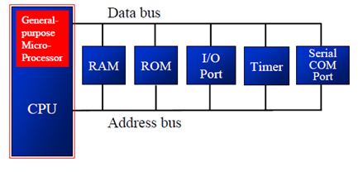

Microcontroller has
- CPU (microprocessor)
- RAM
- ROM
- I/O ports
- Timer
- ADC and other peripherals
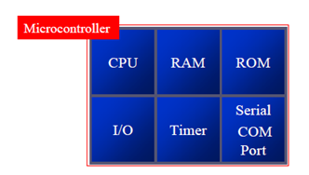
The fixed amount of on-chip ROM, RAM, and number of I/O ports makes them ideal for many applications in which cost and space are critical. In many applications, the space it takes, the power it consumes, and the price per unit are much more critical considerations than the computing power.

What is a microcontroller?
A device which contains the microprocessor with integrated peripherals like memory, serial ports, parallel ports, timer/counter, interrupt controller, data acquisition interfaces like ADC, DAC is called microcontroller

Comparison between Microprocessor and Micro controller
Microprocessor | Microcontroller
1 Microprocessor contains ALU, general purpose registers, stack pointer, program counter, clock timing circuit and interrupt circuit  2 It has many instructions to move data between memory and CPU.  3 It has one or twobithandlinginstructions.  4 Access times for memory and I/O  devices are more  5 Microprocessor based system  requires more hardware | 1.Microcontroller contains the circuitry of  microprocessor and in addition ithas built- in ROM, RAM, I/Odevices, timers and counters.  2. It has one or two instructions to movedata between memory and CPU.  3. It has many bit handling instructions.  4.Less access times for built-in memoryand I/O  devices  5.Microcontroller based system requiresless  hardware reducing PCB size andincreasing the reliability.
************************************************************************************************
Draw and Explain of architecture of 8051 microcontroller. (Nov 2010/May 2010,May 2015) (MAY/JUNE 2016),(NOV/DEC 2014),(APRIL/MAY 2017)(April 2015)(April 2018)
************************************************************************************************
ARCHITECTURE & BLOCK DIAGRAM OF 8051 MICROCONTROLLER
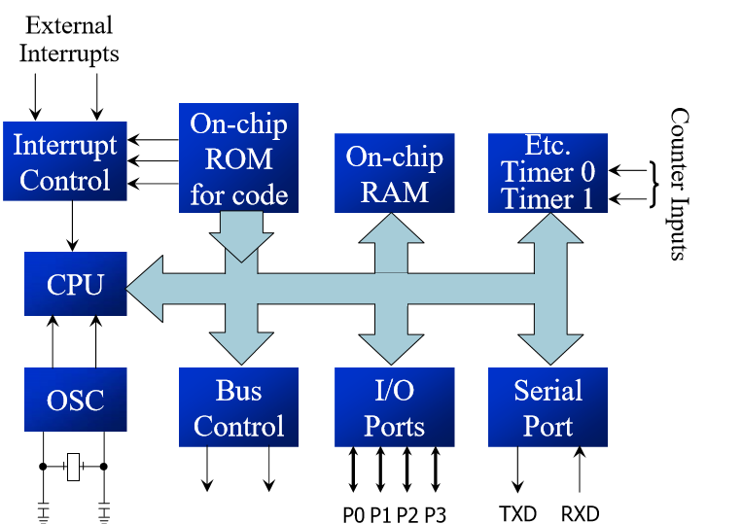
In 1981 ,intel corporation introduced an 8 bit microcontroller called the 8051.The 8051 is an 8-bit processor. The CPU can work on only 8 bits of data at a time. The features of 8051 are

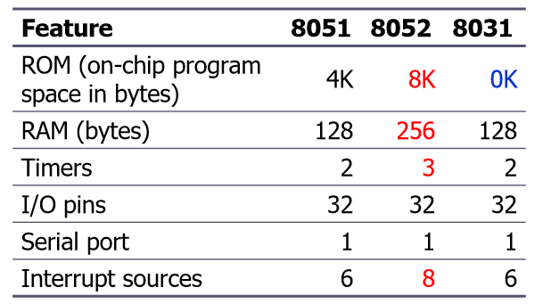
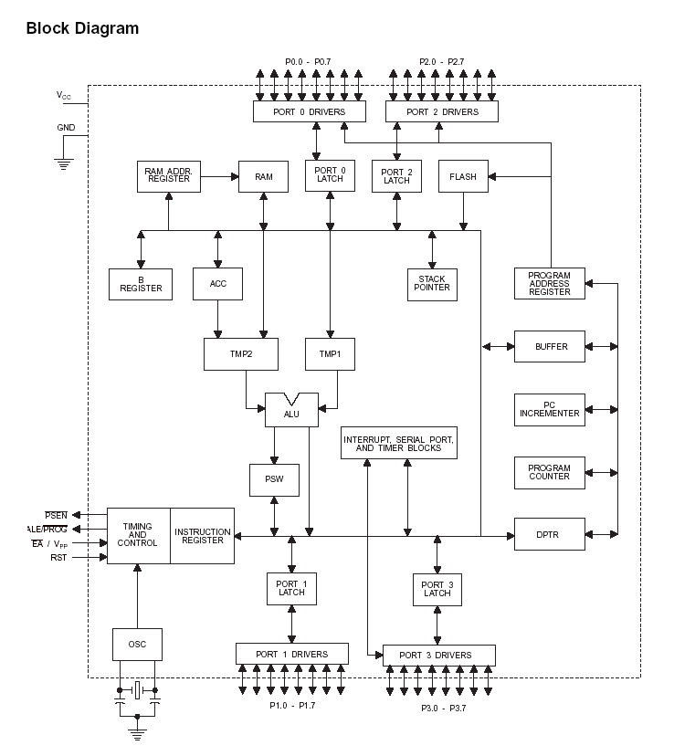
- Registers of 8051

The most widely used registers are
- A (Accumulator) for all arithmetic and logic instructions
- B, R0, R1, R2, R3, R4, R5, R6, R7
- DPTR (data pointer),
- PC (program counter)
- The R registers: The "R" registers are a set of eight registers that are named R0, R1, etc. up to R7. These registers are used as auxiliary registers in many operations. The "R" registers are also used to temporarily store values.
- A and B Registers : The A and B registers are special function registers which hold the results of many arithmetic and logical operations of 8051.
- The A register is also called the Accumulator and as it’s name suggests, is used as a general register to accumulate the results of a large number of instructions.
- By default, it is used for all mathematical operations and also data transfer operations between CPU and any external memory

A
B
R0
R1
R3
R4
R2
R5
R7
R6
DPH
DPL
PC
DPTR
PC
Some 8051 16-bit Register
Some 8-bit Registers of the 8051

All the above registers are 8 bits except DPTR and PC.

Program Counter (PC):
- 8051 has a 16-bit program counter.
- The program counter always points to the address of the next instruction to be executed. After execution of one instruction the program counter is incremented to point to the address of the next instruction to be executed.

Data Pointer Register (DPTR):

- It is a 16-bit register which is the only user-accessible.
- DPTR, as the name suggests, is used to point to data.
- When the 8051 accesses external memory it will access external memory at the address indicated by DPTR.
- This DPTR can also be used as two 8-registers DPH and DPL.

- ROM memory map in 8051 family
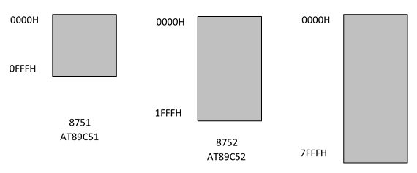
- The microcontroller wakes up at memory address 0000 when it is powered up.
- When 8051 is powered up, the PC has the value of 0000 in it. This means that it expects the first opcode to be stored at ROM address 0000H.
- For this reason, in 8051 system, the first opcode must be burned into memory location 0000H of program ROM.Since this is where it looks for the first instruction when it is booted.
- The first location of on chip ROM of this 8051 has an address of 0000 and the last location has the address of 0FFFH.

3. STACK POINTER (SP)
- The register used to access the stack is called SP (stack pointer) register.
- The stack pointer in the 8051 is only 8 bits wide, which means that it can take value 00 to FFH. When 8051 powered up, the SP register contains value 07.

4. Flag bits and PSW Register:
- The 8051 has an 8-bit Program Status Word register which is also known as Flag register is used to indicate arithmetic conditions and logical conditions such as the carry bits.
- In the 8-bit register, only 6-bits are used by 8051.The two unused bits are user definable bits. In the 6-bits four of them are conditional flags.
- They are Carry –CY, Auxiliary Carry-AC, Parity-P, and Overflow-OV.These flag bits indicate some conditions that resulted after an instruction was executed.
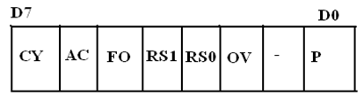
- The bits PSW3 and PSW4 are denoted as RS0 and RS1 and these bits are used to select the bank registers of the RAM location. The meaning of various bits of PSW register is shown below.
CY PSW.7 Carry Flag
AC PSW.6 Auxiliary Carry Flag
FO PSW.5 Flag 0 available for general purpose
RS1 PSW.4 Register Bank select bit 1
RS0 PSW.3 Register bank select bit 0
OV PSW.2 Overflow flag
--- PSW.1 User definable flag
P PSW.0 Parity flagset/cleared by hardware.

The selection of the register Banks and their addresses are given below.
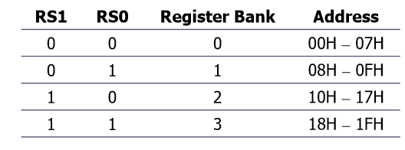
----------------------------------------------------------------------------------------------------------------------------------------------
Explain RAM structure of 8051. [December 2016]
Draw the memory structure of 8051 microcontroller. [December 2017]
--------------------------------------------------------------------------------------------------------------------------------------------
5. 8051 Register Banks and stack pointer

There are 128 bytes of RAM in the 8051 are assigned addresses 00 to 7FH. The 128 bytes are divided into three different groups as follows:
- 1) A total of 32 bytes from locations 00 to 1F hex are set aside for register banks and the stack.
- 2) A total of 16 bytes from locations 20H to 2FH are set aside for bit-addressable read/write memory.
- 3) A total of 80 bytes from locations 30H to 7FH are used for read and write storage, called scratch pad

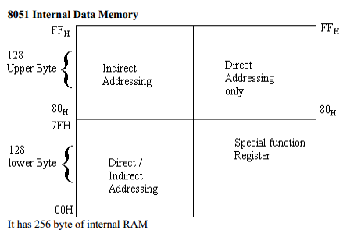
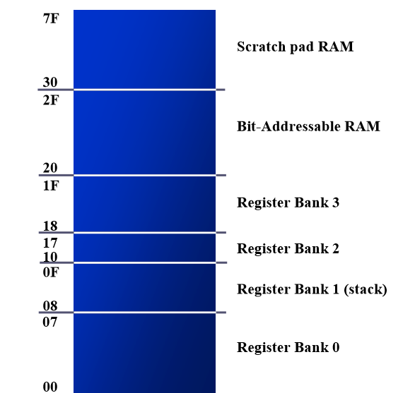
- Fig:RAM memory space allocation in the 8051

Register bank in 8051
- These 32 bytes are divided into 4 banks of registers in which each bank has 8 registers, R0-R7.

- RAM location from 0 to 7 are set aside for bank 0 of R0-R7 where R0 is RAM location 0, R1 is RAM location 1, R2 is RAM location 2, and so on, until memory location 7 which belongs to R7 of bank 0.

- It is much easier to refer to these RAM locations with names such as R0, R1, and so on, than by their memory locations Register bank 0 is the default when 8051 is powered up.

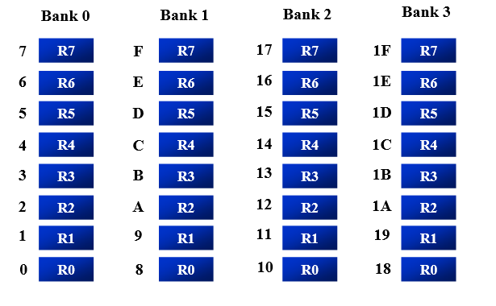

Bit addressable RAM

- The bit-addressable RAM locations are 20H to 2FH.
- These 16 bytes provide 128 bits of RAM bit-addressability, since 16 ×8 = 128. 0 to 127 (in decimal) or 00 to 7FH.
- The first byte of internal RAM location 20H has bit address 0 to 7H
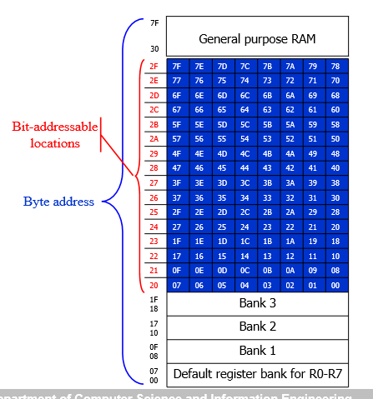
- The last byte of 2FH has bit address 78H to 7FH.Internal RAM locations 20-2FH are both byte-addressable and bit addressable.
- Bit address 00-7FH belong to RAM byte addresses 20-2FH.
- Bit address 80-FFH belong to SFR P0, P1, …
- Only registers A, B, PSW, IP, IE, ACC, SCON, and TCON are bit-addressable.

- While all I/O ports are bit-addressable, In PSW register, two bits are set aside for the selection of the register banks Upon RESET, bank 0 is selected .We can select any other banks using the bit-addressability of the PSW.

Structure of Internal ROM (On –chip ROM):
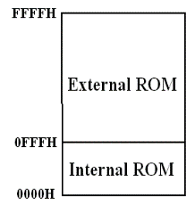

- The 8051 microcontroller has 4kB of on chip ROM but it can be extended up to 64kB.
- This ROM is also called program memory or code memory.
- The CODE segment is accessed using the program counter (PC) for opcode fetches and by DPTR for data.
- The external ROM is accessed when the EA (active low) pin is connected to ground or the contents of program counter exceeds 0FFFH.
- When the Internal ROM address is exceeded the 8051 automatically fetches the code bytes from the external program memory.

6. STACK in 8051

- The stack is a section of RAM used by the CPU to store information temporarily. This information could be data or an address.
- The register used to access the stack is called the SP (stack pointer) register .The stack pointer in the 8051 is only 8 bit wide, which means that it can take value of 00 to FFH.
- When the 8051 is powered up, the SP register contains value 07.RAM location 08 is the first location begin used for the stack by the 8051.
- The storing of a CPU register in the stack is called a PUSH and loading the contents of the stack back into a CPU register is called a POP.

Pushing on to the Stack

SP is pointing to the last used location of the stack ¾As we push data onto the stack, the SP is incremented byone.
. 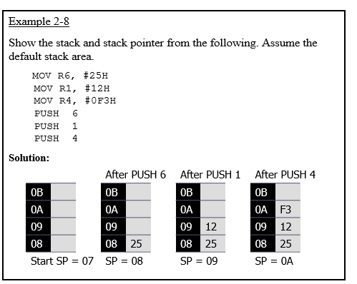

Popping from the stack

With every pop, the top byte of the stack is copied to the register specified by the instruction and the stack pointer is decremented once.

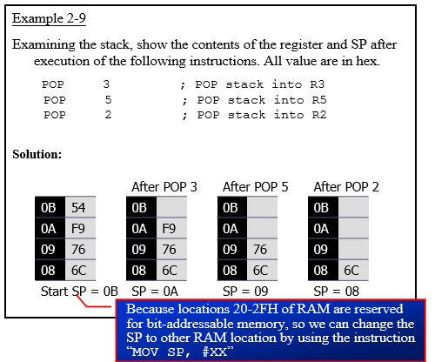

************************************************************************************************

Explain the pin description of 8051 microcontroller. (Dec 2010,June 2013) (Dec 2018)
******************************************************************************************
8051 PIN DIAGRAM

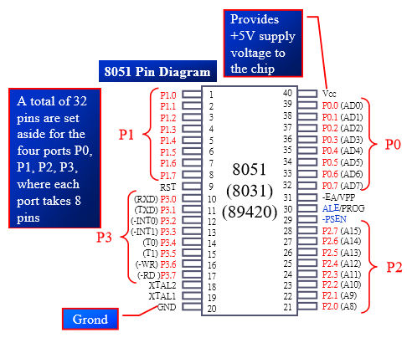

Figure:8051 pin description

The 8051 family members (e.g, 8751, 89C51, 89C52, DS89C4x0) have 40 pins dedicated for various functions such as I/O, -RD, -WR, address, data, and interrupts .They come in different packages, such as DIP(dual in-line package),QFP(quad flat package), and LLC(leadless chip carrier).

- V_{cc} pin 40 provides supply voltage to the chip.The voltage source is
- GND Pin 20 is the ground.
- XTAL1 AND XTAL2 (PIN 19,18)
The 8051 has an on-chip oscillator but requires an external clock to run it .A quartz crystal oscillator is connected to inputs XTAL1 (pin19) and XTAL2 (pin18) .The quartz crystal oscillator also needs two capacitors of 30 pFvalue.
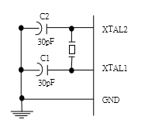
- If you use a frequency source other than a crystal oscillator, such as a TTL oscillator ¾It will be connected to XTAL1.
- XTAL2 is left unconnected
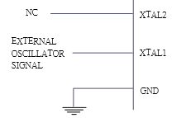
The speed of 8051 refers to the maximum oscillator frequency connected to XTAL.Ex. A 12-MHz chip must be connected to a crystal with 12 MHz frequency or less. We can observe the frequency on the XTAL2 pin using the oscilloscope

- EA（pin 31）：external access
  - There is no on-chip ROM in 8031 and 8032 .so the EA pin is connected to GND to indicate the code is stored externally.
  - EA pin is connected to Vcc because the 8051 family members all come with on-chip ROM to store programs.

- PSEN（pin 29）：Program store enable
  - This is an output pin and is connected to the OE pin of the ROM.

- ALE（pin 30）：Address latch enable
  - The ALE pin is used for de-multiplexing the address and data bus of Port 0 which provides both address and data

- RST（pin 9）：Reset
  - It is a power-on reset.
    - Upon applying a high pulse to RST, the microcontroller will reset and all values in registers will be lost.
  - .
Reset values of some 8051 registers
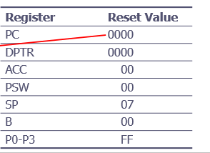

PARELLEL I/O PORTS
I/O port pins
The four ports P0, P1, P2, and P3. Each port uses 8 pins. All I/O pins are bi-directional. All the ports upon RESET are configured as output, ready to be used as output ports. To make the ports as an input port, it must programmed as such by writing 1 to all its bits.
The 8051 has four I/O ports
- Port 0 P0（P0.0～P0.7）
- Port 1 P1（P1.0～P1.7）
- Port 2 P2（P2.0～P2.7）
- Port 3 P3（P3.0～P3.7)
Port 0
- It is also designated as AD0-AD7, allowing it to be used for both address and data.
- When connecting an 8051/31 to an external memory, port 0 provides both address and data.
- The 8051 multiplexes address and data through port 0 to save pins.
- ALE indicates if P0 has address or data
- When ALE=0, it provides data D0-D7
- When ALE=1, it has address A0-A7
- It can be used for input or output, each pin must be connected externally to a 10K ohm pull-up resistor .
- This is due to the fact that P0 is an open drain, unlike P1, P2, and P3 .
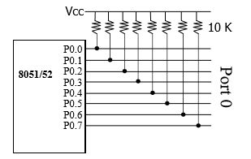
PORT1
Port 1 occupies total of 8 pins 1 to 8 In contrast to Port 0,this port does not need any pull up resistor, since it has already pull up resistors internally.

PORT2
- In 8051-based systems with no external memory connection Both P1 and P2 are used as simple I/O.
- In 8031/51-based systems with external memory connections,Port 2 must be used along with P0 to provide the 16-bit address for the external memory
- P0 provides the lower 8 bits via A₀ –A₇
- P2 is used for the upper 8 bits of the 16-bit address, designated as A8 –A15, and it cannot be used for I/O.
Port 3
- It can be used as input or output.
- Port 3 does not need any pull-up resistors
- Port 3 has the additional function of providing some extremely important signals.
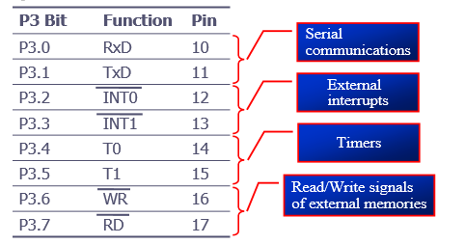

Explain Parallel ports of 8051 with its circuit description in detail. [NOV/DEC 2016, APRIL 2015,April 2018]
************************************************************************************************
PORT 0
Port-0 can be used as a normal bidirectional I/O port or it can be used for address/data interfacing for accessing external memory. When control is '1', the port is used for address/data interfacing. When the control is '0', the port can be used as a bidirectional I/O port
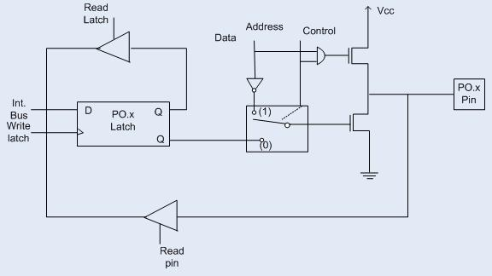
.PORT 0 as an Input Port
Let us assume that control is '0'. When the port is used as an input port, '1' is written to the latch. In this situation both the output MOSFETs are 'off'. Hence the output pin have floats hence whatever data written on pin is directly read by read pin.
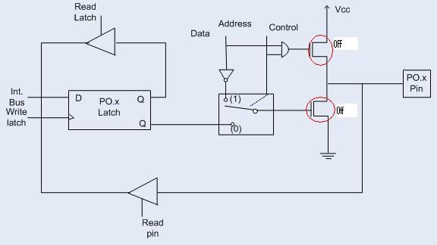

PORT 0 as an Output Port
Suppose we want to write 1 on pin of Port 0, a '1' written to the latch whichturns 'off' the lower FET while due to '0' control signal upper FET also turns off as shown in fig. above. Here we want logic '1' on pin but we getting floating value so to convert that floating value into logic '1' we need to connect the pull up resistor parallel to upper FET. This is the reason why we needed to connect pull up resistor to port 0 when we want to initialize port 0 as an output port.
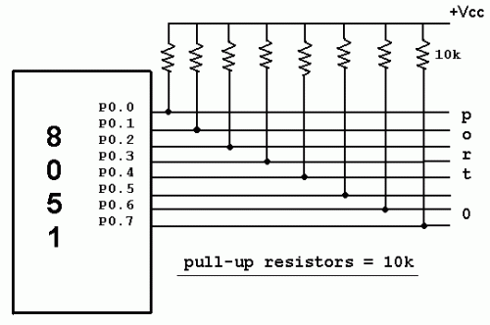
If we want to write '0' on pin of port 0, when '0' is written to the latch, the pin is pulled down by the lower FET. Hence the output becomes zero
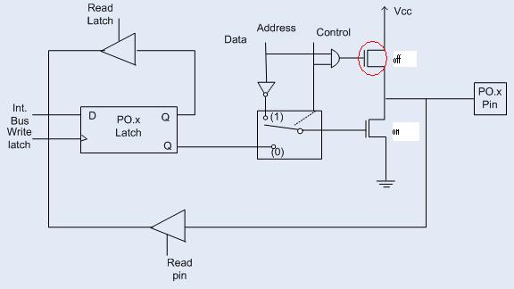
When the control is '1', address/data bus controls the output driver FETs. If the address/data bus (internal) is '0', the upper FET is 'off' and the lower FET is 'on'. The output becomes '0'. If the address/data bus is '1', the upper FET is 'on' and the lower FET is 'off'. Hence the output is '1'. Hence for normal address/data interfacing (for external memory access) no pull-up resistors are required.Port-0 latch is written to with 1's when used for external memory access.

PORT 1:
The structure of a port-1 pin is shown in fig below. It has 8 pins (P1.1-P1.7) .
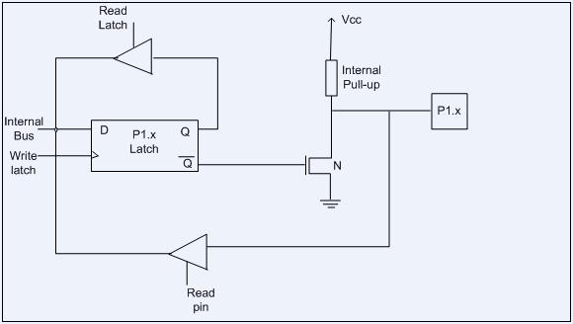

- Port-1 dedicated only for I/O interfacing. When used as output port, not needed to connect additional pull-up resistor like port 0.
- It has provided internally pull-up resistor as shown in fig. below. The pin is pulled up or down through internal pull-up when we want to initialize as an output port.
- To use port-1 as input port, '1' has to be written to the latch. In this input mode when '1' is written to the pin by the external device then it read fine. But when '0' is written to the pin by the external device then the external source must sink current due to internal pull-up.
- If the external device is not able to sink the current the pin voltage may rise, leading to a possible wrong reading.

PORT 2:
The structure of a port-2 pin is shown in fig. below. It has 8-pins (P2.0-P2.7) .
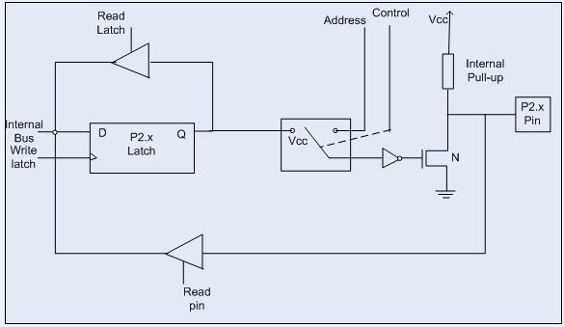

Port-2 we use for higher external address byte or a normal input/output port. The I/O operation is similar to Port-1. Port-2 latch remains stable when Port-2 pin are used for external memory access. Here again due to internal pull-up there is limited current driving capability.

PORT 3:
Port-3 (P3.0-P3.7) having alternate functions to each pin,The internal structure of a port-3 pin is shown in fig below.
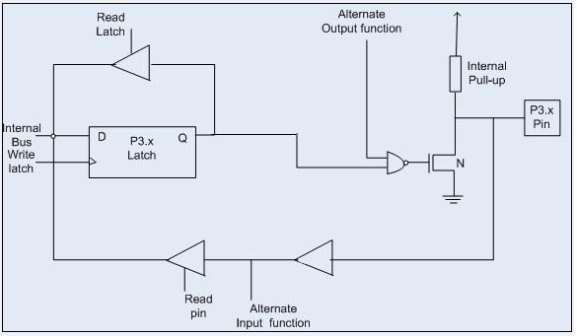
Following are the alternate functions of port 3

*************************************************************************************************

Explain special function register of 8051. (Dec 2010)
________________________________________________________________________________________________

SPECIAL FUNCTION REGISTER
In 8051 microcontroller there are certain registers which uses the RAM addresses from 80h to FFH and they are meant for certain specific operations. These registers are called Special function registers (SFRs).Some of these registers are bit addressable also.
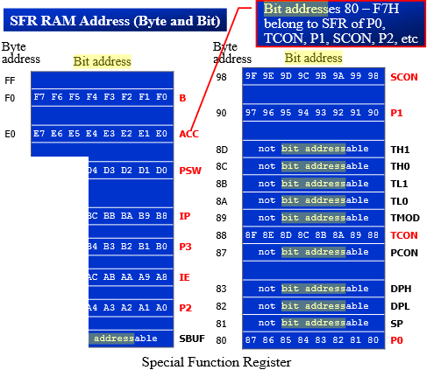
The SFR (Special Function Register ) can be accessed by their names or by their addresses. Not all the address space of 80 to FF is used by SFR.The unused locations 80H to FFH are reserved and must not be used by the 8051 programmer
The list of SFRs and their functional names are given below. In these SFRs some of them are related to I/O ports (P0,P1,P2 and P3) and some of them are meant for control operations (TCON, SCON, PCON) and remaining are the auxillary SFRs, in the sense that they don't directly configure the 8051

S.No | Symbol |  | Name of SFR | Address (Hex)
1 | ACC* |  | Accumulator | 0E0
2 | B* |  | B-Register | 0F0
3 | PSW* |  | Program Status word register | 0DO
4 | SP |  | Stack Pointer Register | 81
5 | DPTR | DPL | Data pointer low byte | 82
5 | DPTR | DPH | Data pointer high byte | 83
6 | P0* |  | Port 0 | 80
 | P1* |  | Port 1 | 90
8 | P2* |  | Port 2 | 0A
9 | P3* |  | Port 3 | 0B
10 | IP* |  | Interrupt Priority control | 0B8
11 | IE* |  | Interrupt Enable control | 0A8
12 | TMOD |  | Tmier mode register | 89
13 | TCON* |  | Timer control register | 88
14 | TH0 |  | Timer 0 Higher byte | 8C
15 | TL0 |  | Timer 0 Lower byte | 8A
16 | TH1 |  | Timer 1Higher byte | 8D
17 | TL1 |  | Timer 1 lower byte | 8B
18 | SCON* |  | Serial control register | 98
19 | SBUF |  | Serial buffer register | 99
20 | PCON |  | Power control register | 87

*************************************************************************************************
Explain the various addressing modes of 8051 microcontroller.
*****************************************************************************************
ADDRESSING MODES OF 8051:

The way in which the data operands are accessed by different instructions is known as the addressing modes. There are various methods of denoting the data operands in the instruction. The 8051 microcontroller supports mainly 5 addressing modes. They are
1. Immediate addressing mode
2. Direct Addressing mode
3. Register addressing mode
4. Register Indirect addressing mode
5. Indexed addressing mode

1. Immediate addressing mode :
The addressing mode in which the data operand is a constant and it is a part of the instruction itself is known as immediate addressing mode. Normally the data must be preceded by a # sign. This addressing mode can be used to transfer the data into any of the registers including DPTR.

Example:
MOV A, # 27 H : The data (constant) 27 is moved to the accumulator register
ADD R1,#45 H : Add the constant 45 to the contents of the accumulator
MOV DPTR ,# 8245H :Move the data 8245 into the data pointer register.
MOV P1,#21 H

2. Direct addressing mode:
The addressing mode in which the data operand is in the RAM location (00 -7FH) and the address of the data operand is given in the instruction is known as Direct addressing mode. The direct addressing mode uses the lower 128 bytes of Internal RAM and the SFRs.
Example:
MOV R1, 42H: Move the contents of RAM location 42 into R1 register
MOV 49H,A: Move the contents of the accumulator into the RAM location 49.
ADD A, 56H: Add the contents of the RAM location 56 to the accumulator

3. Register addressing mode:
The addressing mode in which the data operand to be manipulated lies in one of the registers is known as register addressing mode.
Example:
MOV A, R0: Move the contents of the register R0 to the accumulator
ADD A, R6 :Add the contents of R6 register to the accumulator
MOV P1, R2 : Move the contents of the R2 register into port 1
MOV R5, R2 : This is invalid .The data transfer between the registers is not allowed.

4. Register Indirect addressing mode:
The addressing mode in which a register is used as a pointer to the data memory block is known as Register indirect addressing mode.
Example:
MOV A,@ R0 :Move the contents of RAM location whose address is in R0 into A (accumulator)
MOV @ R1 , B : Move the contents of B into RAM location whose address is held by R1
When R0 and R1 are used as pointers, they must be preceded by @ sign
One of the advantages of register indirect addressing mode is that it makes accessing the data more dynamic than static as in the case of direct addressing mode.

5.Indexed addressing mode :
This addressing mode is usedin accessing the data elements of lookup table entries located in program ROM space of 8051.
Example : MOVC A,@ A+DPTR
The 16-bit register DPTR and register A are used to form the address of the data element stored in on-chip ROM. Here C denotes code .In this instruction the contents of A are added to the 16-bit DPTR register to form the 16-bit address of the data operand.

Explain the Data Transfer Schemes and its types in detail.
************************************************************************************************************************

DATA TRANSFER SCHEMES

  - In a microprocessor-based system, the data transfer takes place between two devices such as microprocessor and memory, microprocessor and I/O devices and memory and I/O devices.
  - A microprocessor based system or a computer may have several I/O devices of different speed.
  - A slow I/O device cannot transfer data because it takes some time to get ready.
  - To solve this problem of speed mismatch between a microprocessor and I/O devices a number of data transfer techniques have been developed.

They are classified into two categories.

- Programmed data transfer scheme
- DMA (Direct Memory Access) data transfer scheme

Programmed Data Transfer Scheme

  - Programmed data transfer scheme are controlled by the CPU.
  - Data are transferred an I/O device to the CPU or vice versa under the control of programs.
  - These programs are executed by the CPU when an I/O device is ready to transfer data.
  - It is used when small amount of data are to be transferred. It is classified into following three categories.

Synchronous Data Transfer Scheme

  - Synchronous means “at the same time”.
  - The device which sends data and the device which receives data are synchronized with the same clock.
  - The data transfer with I/O devices is performed by executing IN or OUT instructions for I/O
mapped I/O devices.

[OR]

  - The data transfer with I/O devices is performed by executing memory read/write instruction for memory mapped I/O devices.
  - In this type of data transfer, the status of the I/O device i.e., whether it is ready or not, is not examined before data are transferred. Hence, this technique is rarely used for I/O devices.

Asynchronous Data Transfer Scheme

    - Asynchronous means “at irregular intervals”.
    - The device which sends data and the device which receives data are not synchronized with the same clock.
    - This technique of data transfer is used when the speed of an I/O device does not match the speed
of the microprocessor and also the timing characteristic of I/O device is not predictable.
    - The status of the I/O device i.e., whether the device is ready or not is checked by the microprocessor before the data are transferred.
    - If it is not ready, the microprocessor initiates the I/O device to get ready and then continuously checks the status of the I/O device till the I/O device becomes ready to transfer data.
    - When I/O device becomes ready, the microprocessor sends instruction to transfer data.
    - This method of data transfer is also called handshaking mode.
    - The microprocessor sends an initiating signal to the I/O device to get ready.
    - When I/O device becomes ready it sends signals to the processor to indicate that it is ready.
Such signals are called handshake signals.

Interrupt Driven Data Transfer Scheme
  - In this scheme, the microprocessor initiates an I/O device to get ready and then it executes its
main program instead of remaining in a program loop to check the status of the I/O device.
  - When the I/O device becomes ready to transfer data, it sends a high signal to the microprocessor through a special input line called an interrupt line.
  - In other word, it interrupts the normal processing sequence of the microprocessor.
  - On receiving the microprocessor completes the current instruction at hand and then attends the I/O device.
  - It saves the contents of the program counter on the stack first and then takes up a subroutine called Interrupt Service Subroutine (ISS).

DMA Transfer Scheme

    - DMA transfer scheme is not controlled by the CPU. Data are directly transferred from an I/O device to the memory or vice versa.
    - The data transfer is controlled by the I/O device or a DMA controller. It is used when large amount of data are to be transferred.
    - DMA data transfer scheme is faster than programmed data transfer scheme.
    - It is used to transfer data from mass storage devices such as hard disks, floppy disks etc.,
    - It is also used for high-speed printers.

DMA data transfer scheme are of the following two types. Burst Mode
  - In which the I/O device withdraws the DMA request only after on the data bytes have been
transferred is called burst mode of data transfer.
  - It is employed by magnetic disk drives.

Cycle Stealing Technique

  - In this technique, a long block of data is transferred by a sequence of DMA cycles.
  - In this method after transferring one byte or several bytes the I/O device withdraws DMA request.
  - This method reduces interference in CPU‟s activities.
  - The interference can be eliminated completely by designing an interfacing circuitry which can steal bus cycle for DMA data transfer only when the CPU is not using the system bus.

**********************************************************************************
******************************************************************************************
Explain the various types of instruction set of 8051 microcontroller. (June 2016)(Dec 2015)(Dec 2017)
******************************************************************************************

INSTRUCTION SET IN 8051 MICROCONTROLLER:

- Arithmetic Instructions:

ADD
  - 8-bit addition between the accumulator (A) and a second operand.
    - The result is always in the accumulator.
    - The CY flag is set/reset appropriately.
    - ADDC
  - 8-bit addition between the accumulator, a second operand and the previous value of the CY flag.
    - Useful for 16-bit addition in two steps.
    - The CY flag is set/reset appropriately.
- DA
  - Decimal adjust the accumulator.
    - Format the accumulator into a proper 2 digit packed BCD number.
    - Operates only on the accumulator.
    - Works only after the ADD instruction.
- SUBB
  - Subtract with Borrow.
    - Subtract an operand and the previous value of the borrow (carry) flag from the accumulator.
      - A ← A - <operand> - CY.
      - The result is always saved in the accumulator.
      - The CY flag is set/reset appropriately.
- INC
  - Increment the operand by one.
    - The operand can be a register, a direct address, an indirect address, the data pointer.
- DEC
  - Decrement the operand by one.
    - The operand can be a register, a direct address, an indirect address.
- MUL AB / DIV AB
  - Multiply A by B and place result in A:B.
  - Divide A by B and place result in A:B.

- logical instructions in 8051

- ANL / ORL
  - Work on byte sized operands or the CY flag.
    - ANL A, Rn
    - ANL A, direct
    - ANL A, @Ri
    - ANL A, #data
    - ANL direct, A
    - ANL direct, #data
    - ANL C, bit
    - ANL C, /bit

- XRL
  - Works on bytes only.
  - CPL / CLR
  - Complement / Clear.
  - Work on the accumulator or a bit.
    - CLR P1.2
- RL / RLC / RR / RRC
  - Rotate the accumulator.
    - RL and RR without the carry
    - RLC and RRC rotate through the carry.
    - SWAP A
  - Swap the upper and lower nibbles of the accumulator.
  - No compare instruction.
  - Built into conditional branching instructions.

- Data Transfer Instructions

- MOV
  - 8-bit data transfer for internal RAM and the SFR.
    - MOV A, Rn
    - MOV A, direct
    - MOV A, @Ri
    - MOV A, #data
    - MOV Rn, A
    - MOV Rn, direct
    - MOV Rn, #data
    - MOV direct, A
    - MOV direct, Rn
    - MOV direct, direct
    - MOV direct, @Ri
    - MOV direct, #data
    - MOV @Ri, A
    - MOV @Ri, direct
    - MOV @Ri, #data
- MOV
  - 1-bit data transfer involving the CY flag
    - MOV C, bit
    - MOV bit, C
- MOV
  - 16-bit data transfer involving the DPTR
    - MOV DPTR, #data
- MOVC
  - Move Code Byte
    - Load the accumulator with a byte from program memory.
    - Must use indexed addressing
    - MOVC A, @A+DPTR
    - MOVC A, @A+PC
- MOVX
  - Data transfer between the accumulator and a byte from external data memory.
    - MOVX A, @Ri
    - MOVX A, @DPTR
    - MOVX @Ri, A
    - MOVX @DPTR, A
- PUSH / POP
  - Push and Pop a data byte onto the stack.
  - The data byte is identified by a direct address from the internal RAM locations.
    - PUSH DPL
    - POP 40H
- XCH
  - Exchange accumulator and a byte variable
    - XCH A, Rn
    - XCH A, direct
    - XCH A, @Ri
- XCHD
  - Exchange lower digit of accumulator with the lower digit of the memory location specified.
    - XCHD A, @Ri
    - The lower 4-bits of the accumulator are exchanged with the lower 4-bits of the internal memory location identified indirectly by the index register.
    - The upper 4-bits of each are not modified.
Explain the various bit manipulation instruction in 8051 with example.(Dec 2018)
- Boolean (or) Bit manipulation instructions in 8051.

- This group of instructions is associated with the single-bit operations of the 8051.
- This group allows manipulating the individual bits of bit addressable registers and memory locations as well as the CY flag.
  - The P, OV, and AC flags cannot be directly altered.
- This group includes:
  - Set, clear, and, or complement, move.
  - Conditional jumps.
- CLR
  - Clear a bit or the CY flag.
    - CLR P1.1
    - CLR C
- SETB
  - Set a bit or the CY flag.
    - SETB A.2
    - SETB C
    - CPL
  - Complement a bit or the CY flag.
    - CPL 40H ; Complement bit 40 of the bit addressable memory
- ORL / ANL
  - OR / AND a bit with the CY flag.
    - ORL C, 20H ; OR bit 20 of bit addressable memory with the CY flag
    - ANL C, /34H ; AND complement of bit 34 of bit addressable memory with the CY flag.
- MOV
  - Data transfer between a bit and the CY flag.
    - MOV C, 3FH ; Copy the CY flag to bit 3F of the bit addressable memory.
    - MOV P1.2, C ; Copy the CY flag to bit 2 of P1.
- JC / JNC
  - Jump to a relative address if CY is set / cleared.
- JB / JNB
  - Jump to a relative address if a bit is set / cleared.
    - JB ACC.2, <label>
- JBC
  - Jump to a relative address if a bit is set and clear the bit.
  - Instructions that are used for signal-bit operations are as following
  - 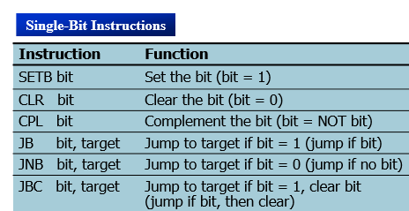

- Branching instructions in 8051.

- The 8051 provides four different types of unconditional jump instructions:
  - Short Jump – SJMP
    - Uses an 8-bit signed offset relative to the 1st byte of the next instruction.
  - Long Jump – LJMP
    - Uses a 16-bit address.
    - 3 byte instruction capable of referencing any location in the entire 64K of program memory.
  - Absolute Jump – AJMP
    - Uses an 11-bit address.
    - 2 byte instruction
      - The upper 3-bits of the address combine with the 5-bit opcode to form the 1st byte and the lower 8-bits of the address form the 2nd byte.
    - The 11-bit address is substituted for the lower 11-bits of the PC to calculate the 16-bit address of the target.
      - The location referenced must be within the 2K Byte memory page containing the AJMP instruction.
  - Indirect Jump – JMP
    - JMP @A + DPTR
- The 8051 provides 2 forms for the CALL instruction:
  - Absolute Call – ACALL
    - Uses an 11-bit address similar to AJMP
    - The subroutine must be within the same 2K page.
  - Long Call – LCALL
    - Uses a 16-bit address similar to LJMP
    - The subroutine can be anywhere.
  - Both forms push the 16-bit address of the next instruction on the stack and update the stack pointer.
- The 8051 provides 2 forms for the return instruction:
  - Return from subroutine – RET
    - Pop the return address from the stack and continue execution there.

  - Return from ISV – RETI
    - Pop the return address from the stack.
    - Restore the interrupt logic to accept additional interrupts at the same priority level as the one just processed.
    - Continue execution at the address retrieved from the stack.
    - The PSW is not automatically restored.

- The 8051 supports 5 different conditional jump instructions.
  - ALL conditional jump instructions use an 8-bit signed offset.
  - Jump on Zero – JZ / JNZ
    - Jump if the A == 0 / A != 0
      - The check is done at the time of the instruction execution.
  - Jump on Carry – JC / JNC
    - Jump if the C flag is set / cleared.
  - Jump on Bit – JB / JNB
    - Jump if the specified bit is set / cleared.
    - Any addressable bit can be specified.
  - Jump if the Bit is set then Clear the bit – JBC
    - Jump if the specified bit is set.
    - Then clear the bit.
- Compare and Jump if Not Equal – CJNE
  - Compare the magnitude of the two operands and jump if they are not equal.
    - The values are considered to be unsigned.
    - The Carry flag is set / cleared appropriately.
    - CJNE A, direct, rel
    - CJNE A, #data, rel
    - CJNE Rn, #data, rel
    - CJNE @Ri, #data, rel
- Decrement and Jump if Not Zero – DJNZ
  - Decrement the first operand by 1 and jump to the location identified by the second operand if the resulting value is not zero.
    - DJNZ Rn, rel
    - DJNZ direct, rel
- No Operation
  - NOP

Basic I/O Instructions

- IN, OUT, INS and OUTS are the instructions for the transfer of data to and from an I/O device.
- IN and OUT transfer data between an I/O device and the microprocessor's accumulator (AL, AX or EAX).
The I/O address is stored in:
- Register DX as a 16-bit I/O address (variable addressing).
- The byte, D8, immediately following the opcode (fixed address).
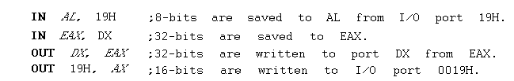

- Only 16-bits (A0 to A15) are decoded.
- Address connections above A15 are undefined for I/O instructions.
- 0000H-03XXH are used for the ISA bus.
- INS and OUTS transfer to I/O devices using ES:DI and DS:SI, respectively.

***********************************************************************************************
With a neat Diagram explain what is interrupts and types of interr upts in 8051. [NOV/DEC 2016 , MAY/JUNE 2016, APRIL/MAY 2015]
************************************************************************************************
Interrupt Programming
An interrupt is an external or internal event that interrupts the microcontroller to inform it that a device needs its service.A single microcontroller can serve several devices by two ways
- Polling
- The microcontroller continuously monitors the status of a given device
- When the conditions met, it performs the service.
- After that, it moves on to monitor the next device until every one is serviced

Polling can monitor the status of several devices and serve each of them as certain conditions are met The polling method is not efficient, since it wastes much of the microcontroller’s time by polling devices that do not need service
ex. JNB TF,target

- Interrupts
- Whenever any device needs its service, the device notifies the microcontroller by sending it an interrupt signal
- Upon receiving an interrupt signal, the microcontroller interrupts whatever it is doing and serves the device
- The program which is associated with the interrupt is called the interrupt service routine (ISR) or interrupt handler.

For every interrupt, there must be an interrupt service routine (ISR), or interrupt handler
- When an interrupt is invoked, the microcontroller runs the interrupt service routine.
- For every interrupt, there is a fixed location in memory that holds the address of its ISR.
- The group of memory locations set aside to hold the addresses of ISRs is called interrupt vector table

- Steps in executing an interrupt
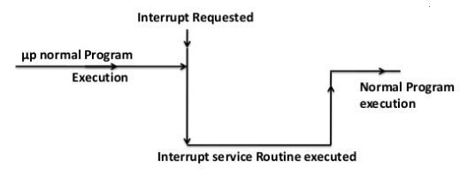
Figure: Interrupt service routine
1. Finish current instruction and saves the address of the next instruction (PC) on the stack
2. It jumps to a fixed location in memory called the interrupt vector table that holds the address of the
ISR.
4. It starts to execute the interrupt service subroutine until it reaches the last instruction of the subroutine which is RETI (return from interrupt)
5. Upon executing the RETI instruction, the microcontroller returns to the place where it was interrupted. Get POP PC from Stack.
6. Then it starts to execute from that address
- Interrupt Sources
Six interrupts are allocated as follows
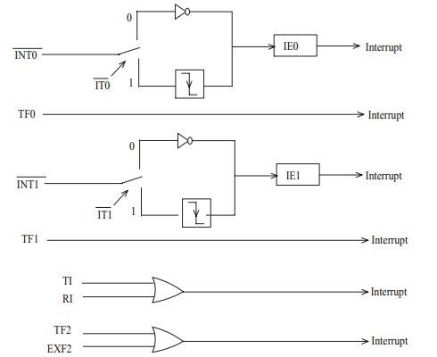
Figure: 8051 Interrupt sources
- Interrupt Vectors

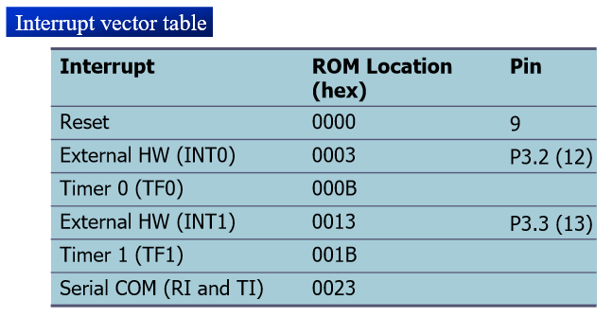
Upon reset, all interrupts are disabled (masked), meaning that none will be responded to by the microcontroller if they are activated
- The interrupts must be enabled by software in order for the microcontroller to respond to them.
- There is a register called IE (interrupt enable) that is responsible for enabling (unmasking) and disabling (masking) the interrupts.
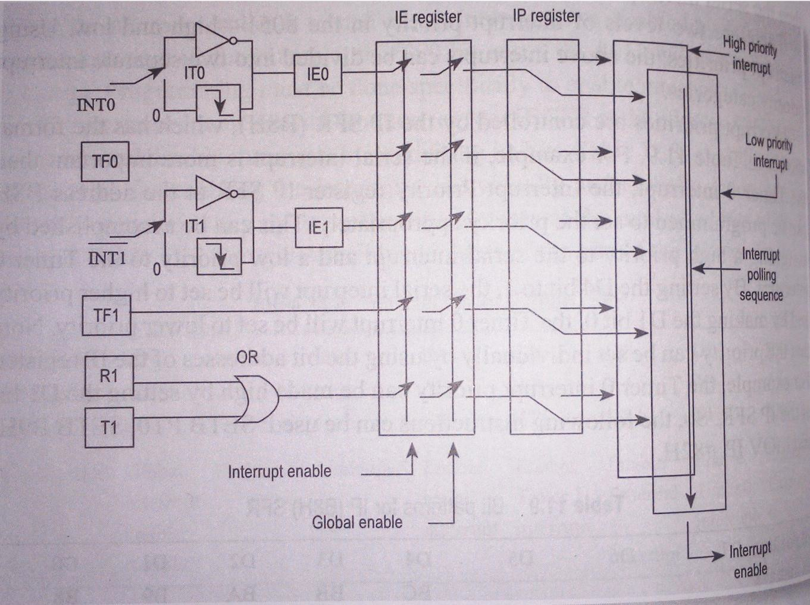
Fig:Interrupt structure of 8051
- Interrupt Related Register
The various registers associated with interrupts are
- Interrupt Enable (IE)
- Interrupt Priority(IP)
- Timer control TCON)
- Serial control(SCON)
- Interrupt Enable (IE)Register( Enabling and Disabling)
EA | ----- | ET2 | ES | ET1 | EX1 | ET0 | EX0
D₇ | D₆ | D₅ | D₄ | D₃ | D₂ | D₁ | D₀

- EX0/EX1 : Enables(1)/disables(0) the external interrupt 0 and the external interrupt 1 on port P3.2 / P3.3
- ET0/ET1 : Enables(1)/disables(0) the Timer0 and Timer1 interrupt via TF0/1
- ES : Enables(1)/disables(0) the serial port interrupt for sending and receiving data
- EA : Enables(1)/disables(0) all interrupts
To enable an interrupt, we take the following steps:
1. Bit D7 of the IE register (EA) must be set to high to allow the rest of register to take effect
2. The value of EA

- If EA = 1, interrupts are enabled and will be responded to if their corresponding bits in IE are high
- If EA = 0, no interrupt will be responded to, even if the associated bit in the IE register is high.

- Interrupt Priority(IP)Register
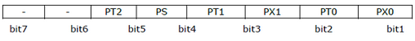
- PS- IP.4- Serial Port Interrupt Priority bit
• PT1- IP.3- Timer 1 Interrupt Priority bit
• PX1- IP.2 External Interrupt 1 Priority bit
• PT0- IP.1 Timer 0 Interrupt Priority bit
• PX0- IP.0 External Interrupt 0 Priority bit
When the 8051 is powered up, the priorities are assigned according to the following
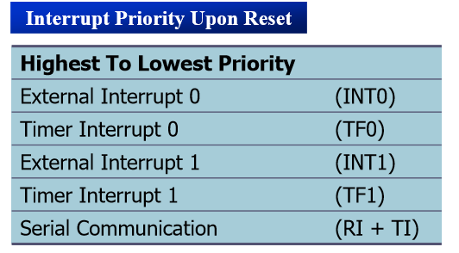
We can alter the sequence of interrupt priority by assigning a higher priority to any one of the interrupts by programming a register called IP (interrupt priority)
- To give a higher priority to any of the interrupts, we make the corresponding bit in the IP register high When two or more interrupt bits in the IP register are set to high
- While these interrupts have a higher priority than others, they are serviced according to the sequence of Table.
- TCON (Timer control register)
It is used to select edge and type of external interrupts EX0 and EX1.
TCON (timer control) register is an 8-bit register. TCON register is a bit-addressable register

TF1 | TR1 | TF0 | TR0 | IE1 | IT1 | IE0 | IT0
D₇ | D₆ | D₅ | D₄ | D₃ | D₂ | D₁ | D₀

- TF1: Timer 1 overflow flag.
- TR1: Timer 1 run control bit.
- TF0: Timer 0 overflag.
- TR0: Timer 0 run control bit.
- IE1: External interrupt 1 edge flag.
- IT1: External interrupt 1 type flag.
- IE0: External interrupt 0 edge flag.
- IT0: External interrupt 0 type flag
- SCON Register(Serial control register)
Used to set RI and TI interrupt flags of serial communication

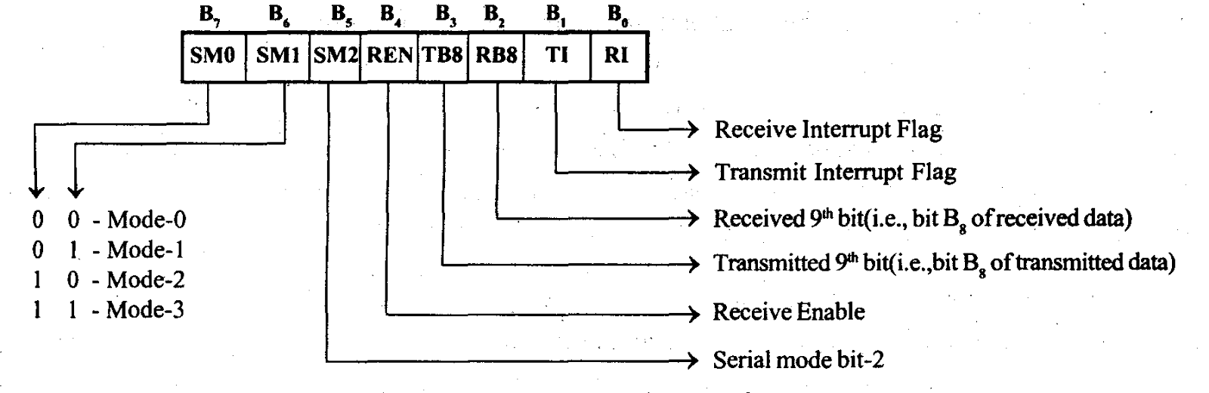
*************************************************************************************************
Timer Interrupt Programming

The timer flag (TF) is raised when the timer rolls over
In polling TF, we have to wait until the TF is raised
- The problem with this method is that the microcontroller is tied down while waiting for TF to be raised, and cannot do anything else
Using interrupts solves this problem and, avoids tying down the controller
- If the timer interrupt in the IE register is enabled, whenever the timer rolls over, TF is raised, and the microcontroller is interrupted in whatever it is doing, and jumps to the interrupt vector table to service the ISR.
- In this way, the microcontroller can do other until it is notified that the timer has rolled over.
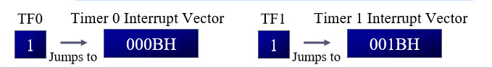
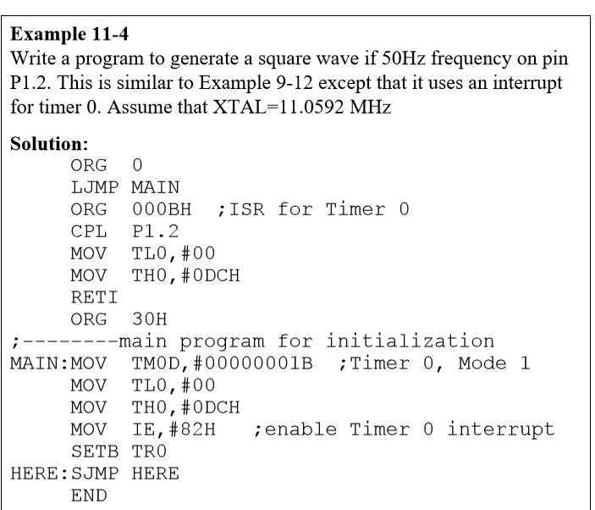
The 8051 has two external hardware interrupts
- Pin 12 (P3.2) and pin 13 (P3.3) of the 8051, designated as INT0 and INT1, are used as external hardware interrupts
- The interrupt vector table locations 0003H and 0013H are set aside for INT0 and INT1
- There are two activation levels for the external hardware interrupts
- Level triggered
- Edge triggered
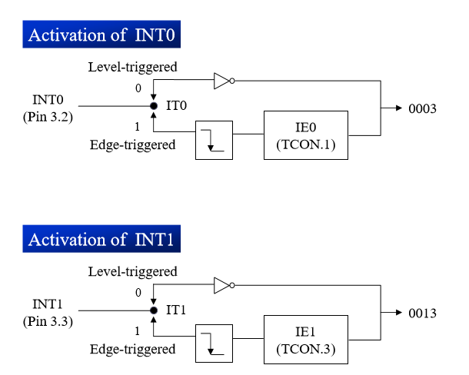
In the level-triggered mode, INT0 and INT1 pins are normally high
- If a low-level signal is applied to them, it triggers the interrupt
- Then the microcontroller stops whatever it is doing and jumps to the interrupt vector table to service that interrupt
- The low-level signal at the INT pin must be removed before the execution of the last instruction of the ISR, RETI; otherwise, another interrupt will be generated
- This is called a level-triggered or level activated interrupt and is the default mode upon reset of the 8051
Pins P3.2 and P3.3 are used for normal I/O unless the INT0 and INT1 bits in the IE register are enabled
- After the hardware interrupts in the IE register are enabled, the controller keeps sampling the INTn pin for a low-level signal once each machine cycle
- According to one manufacturer’s data sheet,
- The pin must be held in a low state until the start of the execution of ISR
- If the INTnpin is brought back to a logic high before the start of the execution of ISR there will be no interrupt
- If INTnpin is left at a logic low after the RETI instruction of the ISR, another interrupt will be activated after one instruction is executed
- To ensure the activation of the hardware interrupt at the INTnpin, make sure that the duration of the low-level signal is around 4 machine cycles, but no more .

- This is due to the fact that the level-triggered interrupt is not latched
- Thus the pin must be held in a low state until the start of the ISR execution
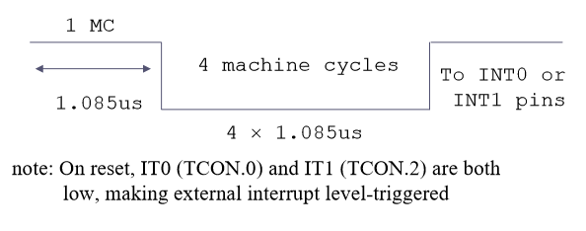
To make INT0 and INT1 edge triggered interrupts, we must program the bits of the TCON register
- The TCON register holds, among other bits, the IT0 and IT1 flag bits that determine level-or edge-triggered mode of the hardware interrupt
- IT0 and IT1 are bits D0 and D2 of the TCON register
- They are also referred to as TCON.0 and TCON.2 since the TCON register is bitaddressable.

In edge-triggered interrupts
- The external source must be held high for at least one machine cycle, and then held low for at least one machine cycle
- The falling edge of pins INT0 and INT1 are latched by the 8051 and are held by the TCON.1 and TCON.3 bits of TCON register
- Function as interrupt-in-service flags
- It indicates that the interrupt is being serviced now and on this INTn pin, and no new interrupt will be responded to until this service is finished
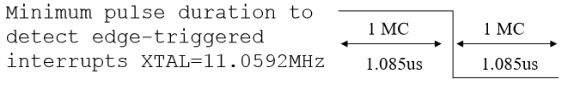

In the 8051 there is only one interrupt set aside for serial communication
- This interrupt is used to both send and receive data
- If the interrupt bit in the IE register (IE.4) is enabled, when RI or TI is raised the 8051 gets interrupted and jumps to memory location 0023H to execute the ISR
- In that ISR we must examine the TI and RI flags to see which one caused the interrupt and respond accordingly.
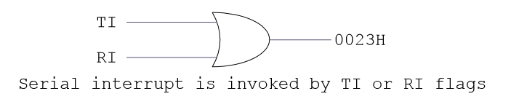

Explain Timer modes of 8051 microcontroller.(April 2017)
****************************************************************************************
PROGRAMMING TIMERS OF 8051
- Timer Registers.
The 8051 has two timers/counters, they can be used either as
- Timers are used to generate a time delay or as Event counters to count events happening outside the microcontroller.
Both Timer0 and Timer1 registers are 16 bits wide.
- Since 8051 has an 8-bit architecture, each 16-bits timer is accessed as two separate registers of low byte and high byte. The low byte register is called TL0/TL1 and the high byte register is called TH₀/TH₁.It can be accessed like any other register
For example MOV TL₀,#4FH
MOV R₅, TH₀

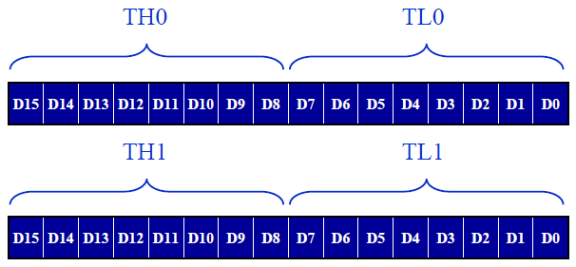
Figure:Timer Registers

- TMOD (Timer mode Register)

Both timers 0 and 1 use the same register, called TMOD (timer mode), to set the various timer operation modes
- TMOD is an 8-bit register
- The lower 4 bits are for Timer 0
- The upper 4 bits are for Timer 1

In each case,
- The lower 2 bits are used to set the timer mode
- The upper 2 bits to specify the operation
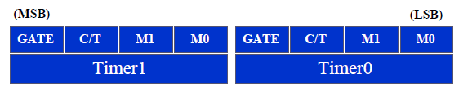
Figure:TMOD Register

- Gate : When set, timer only runs while INT(0,1) is high.
- C/T : Counter/Timer select bit.
- M1 : Mode bit 1.
- M0 : Mode bit 0.

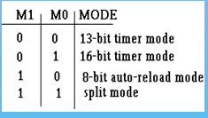

Timers of 8051 do starting and stopping by either software or hardware control
For using software to start and stop the timer where GATE = 0
- The start and stop of the timer are controlled by way of software by the TR (timer start) bits TR0 and TR1

- The SETB instruction starts it, and it is stopped by the CLR instruction.
- These instructions start and stop the timers as long as GATE=0 in the TMOD register
- The hardware way of starting and stopping the timer by an external source is achieved by
making GATE=1 in the TMOD register.
- The another register used in timer programming is TCON register.
- TCON (Timer control register)
TCON (timer control) register is an 8-bit register. TCON register is a bit-addressable register

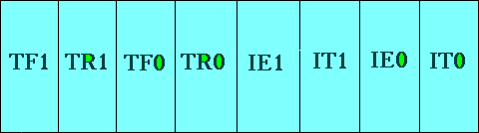

- TF1: Timer 1 overflow flag.
- TR1: Timer 1 run control bit.
- TF0: Timer 0 overflag.
- TR0: Timer 0 run control bit.
- IE1: External interrupt 1 edge flag.
- IT1: External interrupt 1 type flag.
- IE0: External interrupt 0 edge flag.
- IT0: External interrupt 0 type flag.
Modes of operation of 8051 timers

: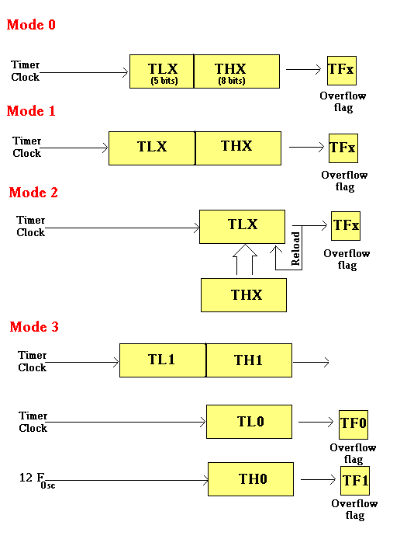

MODE 1:16 bit Timer
The following are the characteristics and operations of mode1:
1. It is a 16-bit timer; therefore, it allows value of 0000 to FFFFH to be loaded into the timer’s register TL and TH
2. After TH and TL are loaded with a 16-bit initial value, the timer must be started.
- This is done by SETB TR0 for timer 0 and SETB TR1 for timer 1
3. After the timer is started, it starts to count up
- It counts up until it reaches its limit of FFFFH
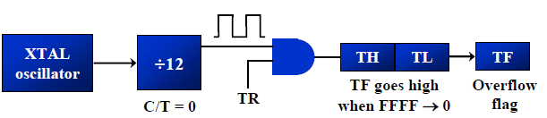
- When it rolls over from FFFFH to 0000, it sets high a flag bit called TF (timer flag)
- Each timer has its own timer flag: TF0 for timer 0, and TF1 for timer 1. This timer flag can be monitored
- When this timer flag is raised, one option would be to stop the timer with the instructions CLR TR0 or CLR TR1, for timer 0 and timer 1, respectively.
- . After the timer reaches its limit and rolls over, in order to repeat the process TH and TL must be reloaded with the original value, and TF must be reloaded to 0.
To generate a time delay

1. Load the TMOD value register indicating which timer (timer 0 or timer 1) is to be used and which timer mode (0 or 1) is selected
2. Load registers TL and TH with initial count value
3. Start the timer
4. Keep monitoring the timer flag (TF) with the JNB TFx ,target instruction to see if it is raised
- Get out of the loop when TF becomes high
5. Stop the timer
6. Clear the TF flag for the next round
7. Go back to Step 2 to load TH and TL again.
MODE 2:8 bit Timer Autoreload

The following are the characteristics and operations of mode 2:
1. It is an 8-bit timer; therefore, it allows only values of 00 to FFH to be loaded into the timer’s register TH
2. After TH is loaded with the 8-bit value,the 8051 gives a copy of it to TL
- Then the timer must be started
- This is done by the instruction SETB TR0 for timer 0 and SETB TR1 for timer 1
3. After the timer is started, it starts to count up by incrementing the TL register
- It counts up until it reaches its limit of FFH
- When it rolls over from FFH to 00, it sets high the TF (timer flag)
- When the TL register rolls from FFH to 0 and TF is set to 1, TL is reloaded automatically with the
original value kept by the TH register.

- To repeat the process, we must simply clear TF and let it go without any need by the programmer to
reload the original value.

- This makes mode 2 an auto-reload, in contrast with mode 1 in which the programmer has to reload TH
and TL.
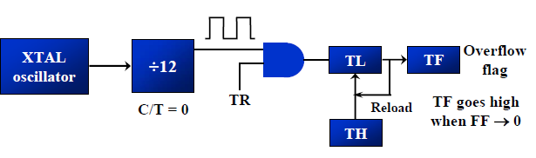
To generate a time delay
- Load the TMOD value register indicating which timer (timer 0 or timer 1) is to be used, and the timer mode (mode 2) is selected
2. Load the TH registers with the initial count value
3. Start timer
4. Keep monitoring the timer flag (TF) with the JNB TFx, target instruction to see whether it is raised
- Get out of the loop when TF goes high
5. Clear the TF flag
6. Go back to Step4, since mode 2 is autoreload.
Timers as counters

- Timers can also be used as counters which are used for counting events happening outside the 8051.

- When it is used as a counter, it is a pulse outside of the 8051 that increments the TH, TL register.
- TMOD and TH, TL registers are the same as for the timer discussed previously except the source of
the frequency The C/T bit in the TMOD registers decides the source of the clock for the timer.
- When C/T = 1, the timer is used as a counter and gets its pulses from outside the 8051.
- The counter counts up as pulses are fed from pins 14 and 15, these pins are called T0 (timer0 input)
and T1 (timer 1 input).

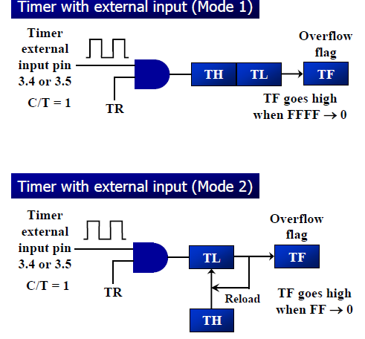
- If GATE = 1, the start and stop of the timer are done externally through pins P3.2 and P3.3 for timers 0 and 1, respectively
- This hardware way allows to start or stop the timer externally at any time via a simple switch
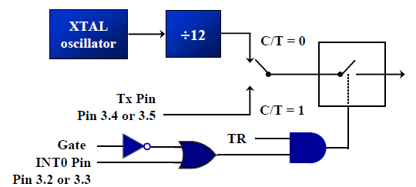
- The frequency for the timer is always 1/12th the frequency of the crystal attached to the 8051, regardless of the 8051 version.

.Explain the serial programming of 8051 with its associated registers.[December 2017]
Explain how to program for sending and receiving data serially using 8051.
SERIAL COMMUNICATION PROGRAMMING
Computers transfer data in two ways:
- Parallel
Often 8 or more lines (wire conductors) are used to transfer data to a device that is only a few feet away
- Serial
To transfer to a device located many meters away, the serial method is used.The data is sent one bit at a time.

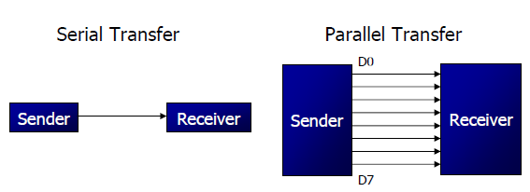

At the transmitting end, the byte of data must be converted to serial bits using parallel-in-serial-out shift register
- At the receiving end, there is a serial in- parallel-out shift register to receive the serial data and pack them into byte.
- When the distance is short, the digital signal can be transferred as it is on a simple wire and requires no modulation.
- If data is to be transferred on the telephone line, it must be converted from 0s and 1s to audio tones. This conversion is performed by a device called a modem, “Modulator/demodulator.

Serial data communication uses two methods
  - Synchronous method transfers a block of data at a time.
  - Asynchronous method transfers a single byte at a time.
It is possible to write software to use either of these methods, but the programs can be tedious and long
There are special IC chips made by many manufacturers for serial communications
- UART (universal asynchronous Receiver/transmitter)
- USART (universal synchronous-asynchronous Receiver-transmitter)
- If data can be transmitted and received, it is a duplex transmission
- If data transmitted one way a time, it is referred to as half duplex.
- If data can go both ways at a time, it is full duplex.
- This is contrast to simplex transmission.

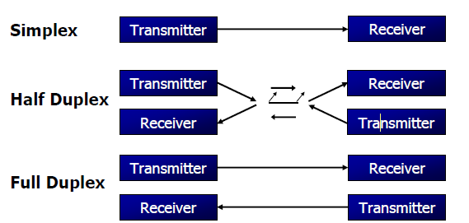
Asynchronous serial data communication is widely used for character-oriented transmissions.
􀂾 Each character is placed in between start and stop bits, this is called framing.
􀂾 Block-oriented data transfers use the synchronous method
􀂉 The start bit is always one bit, but the stop bit can be one or two bits .The start bit is always a 0 (low) and the stop bit(s) is 1 (high)
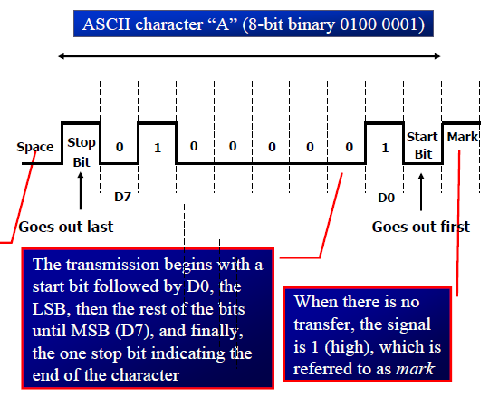
The rate of data transfer in serial data communication is stated in bps (bits per second).Another widely used terminology for bps is baud rate

RS232
It is an interfacing standard RS232 was set by the Electronics Industries Association (EIA) in 1960. The standard was set long before the advent of the TTL logic family, its input and output voltage levels are not TTL compatible
In RS232, a 1 is represented by -3 ~ -25 V,while a 0 bit is +3 ~ +25 V, making -3 to +3 undefined Since not all pins are used in PC cables,IBM introduced the DB-9 version of the serial I/O standard
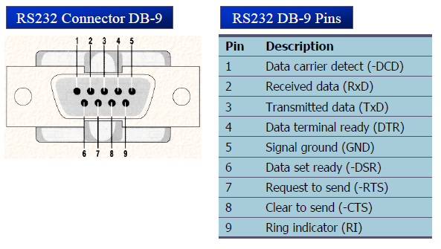
Handshake signals of MODEM

DTR (data terminal ready)
When terminal is turned on, it sends out signal DTR to indicate that it is ready for communication

DSR (data set ready)
When DCE is turned on and has gone through the self-test, it assert DSR to indicate that it is ready to communicate
RTS (request to send)
When the DTE device has byte to transmit,it assert RTS to signal the modem that it has a byte of data to transmit
CTS (clear to send)
When the modem has room for storing the data it is to receive, it sends out signal CTS to DTE to indicate that it can receive the data now.
DCD (data carrier detect)
The modem asserts signal DCD to inform the DTE that a valid carrier has been detected and that contact between it and the other modem is established
RI (ring indicator)
An output from the modem and an input to a PC indicates that the telephone is ringing
It goes on and off in synchronous with the ringing sound.

MAX232

MAX232 chip is called as a line driver which is required to convert RS232 voltage levels to TTL levels, and vice versa.
- 8051 has two pins that are used specifically for transferring and receiving data serially.
- These two pins are called TxD and RxD and are part of the port 3 group (P3.0 and P3.1).
- These pins are TTL compatible; therefore, they require a line driver to make them RS232 compatible. We need a line driver (voltage converter) to convert the R232’s signals to TTL voltage levels that will be acceptable to 8051’s TxD and RxD pins.
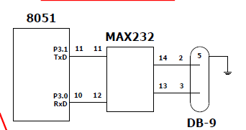
A line driver such as the MAX232 chip is required to convert RS232 voltage levels to TTL levels, and vice versa .
- 8051 has two pins that are used specifically for transferring and receiving data serially.
- These two pins are called TxD and RxD and are part of the port 3 group (P3.0 and P3.1).
- These pins are TTL compatible; therefore,they require a line driver to make them RS232. compatible.

SBUF is an 8-bit register used solely for serial communication.
- For a byte data to be transferred via the TxD line, it must be placed in the SBUF register.
- The moment a byte is written into SBUF, it is framed with the start and stop bits and transferred serially via the TxD line.
- SBUF holds the byte of data when it is received by 8051 RxD line.
- When the bits are received serially via RxD, the 8051 deframes it by eliminating the stop and
- start bits, making a byte out of the data received.

SCON is an 8-bit register used to program the start bit, stop bit, and data bits of data framing, among other things
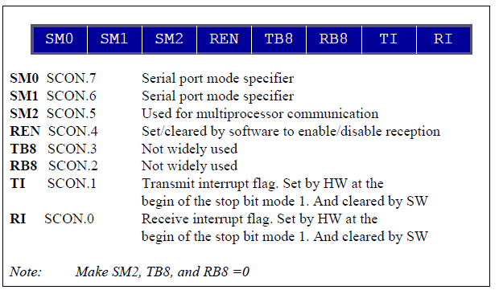

SM0, SM1
They determine the framing of data by specifying the number of bits per character, and the start and stop bits
This enables the multiprocessing capability of the 8051
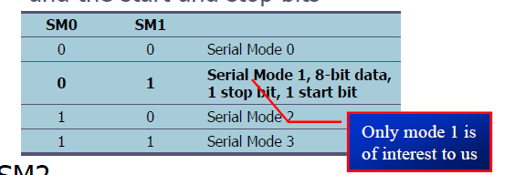

When 8051 receives data serially via RxD, it gets rid of the start and stop bits and places the byte in SBUF register
􀂃 It raises the RI flag bit to indicate that a byte has been received and should be picked up
before it is lost
􀂃 RI is raised halfway through the stop bit
In programming the 8051 to transfer character bytes serially

1. TMOD register is loaded with the value 20H, indicating the use of timer 1 in mode 2 (8-bit auto-reload) to set baud rate.
2. The TH1 is loaded with one of the values to set baud rate for serial data transfer
3. The SCON register is loaded with the value 50H, indicating serial mode 1, where an 8-bit data is framed with start and stop bits
4. TR1 is set to 1 to start timer 1
5. TI is cleared by CLR TI instruction
6. The character byte to be transferred serially is written into SBUF register
7. The TI flag bit is monitored with the use of instruction JNB TI,xx to see if the character has been transferred completely.
8. To transfer the next byte, go to step 5.
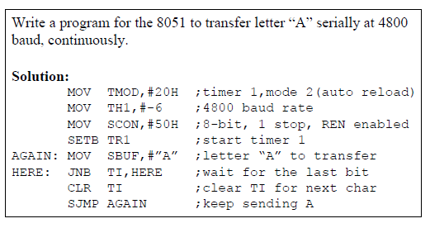
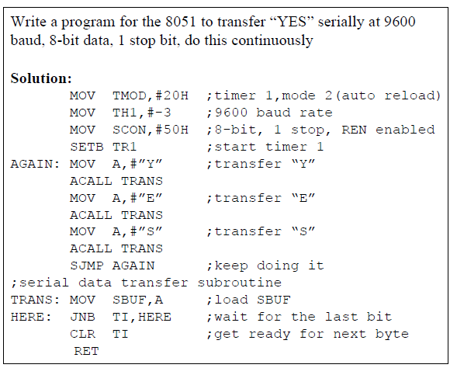
The steps that 8051 goes through in transmitting a character via TxD
1. The byte character to be transmitted is written into the SBUF register
2. The start bit is transferred
3. The 8-bit character is transferred on bit at a time
4. The stop bit is transferred

- It is during the transfer of the stop bit that 8051 raises the TI flag, indicating that the last
character was transmitted
5. By monitoring the TI flag, we make sure that we are not overloading the SBUF
- If we write another byte into the SBUF before TI is raised, the un transmitted portion of the
previous byte will be lost
6. After SBUF is loaded with a new byte, the TI flag bit must be forced to 0 by CLR TI in order for this new byte to be transferred
- By checking the TI flag bit, we know whether or not the 8051 is ready to transfer another byte
- It must be noted that TI flag bit is raised by 8051 itself when it finishes data transfer
- It must be cleared by the programmer with instruction CLR TI
- If we write a byte into SBUF before the TI flag bit is raised, we risk the loss of a portion of the byte being transferred
- The TI bit can be checked by
- The instruction JNB TI,xx Using an interrupt
In programming the 8051 to receive character bytes serially
1. TMOD register is loaded with the value 20H, indicating the use of timer 1 in mode
2 (8-bit auto-reload) to set baud rate
2. TH1 is loaded to set baud rate
3. The SCON register is loaded with the value 50H, indicating serial mode 1, where an 8-bit data is framed with start and stop bits
4. TR1 is set to 1 to start timer 1
5. RI is cleared by CLR RI instruction
6. The RI flag bit is monitored with the use of instruction JNB RI,xx to see if an entire character has been received yet
7. When RI is raised, SBUF has the byte, its contents are moved into a safe place.
8. To receive the next character, go to step 5.
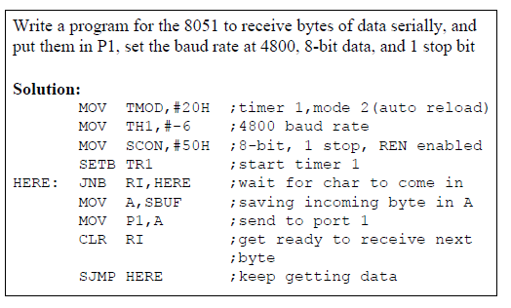
In receiving bit via its RxD pin, 8051 goes through the following steps.
1. It receives the start bit
- Indicating that the next bit is the first bit of the character byte it is about to receive
2. The 8-bit character is received one bit at time
3. The stop bit is received
- When receiving the stop bit 8051 makes RI = 1,indicating that an entire character byte has
been received and must be picked up before itgets overwritten by an incoming character
raised, we know that a character has been received and is sitting in the SBUF register
- We copy the SBUF contents to a safe place in some other register or memory before it is lost
5. After the SBUF contents are copied into a safe place, the RI flag bit must be forced to 0 by CLR RI in order to allow the next received character byte to be placed in SBUF.
- Failure to do this causes loss of the received character.

There are two ways to increase the baud rate of data transfer
- To use a higher frequency crystal
- To change a bit in the PCON register
PCON
- PCON register is an 8-bit register
- When 8051 is powered up, SMOD is zero. We can set it to high by software and thereby double the baud rate.
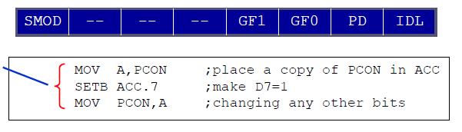
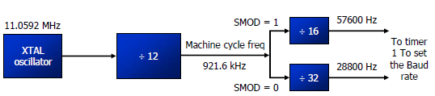

*************************************************************************************************
Explain the interfacing of external RAM and ROM with 8051.
Write short notes on memory addressing (November 2007,December 2017)
Explain how to access external memory devices in an 8051 based system.
Interfacing to external memory

For 8751/89C51/DS5000-based system,
EA (External access)
- we connected the EA pin to Vcc to indicate that the program code is stored in the microcontroller’s
on-chip ROM
- To indicate that the program code is stored in external ROM, this pin must be connected to GND.

Since the PC (program counter) of the 8031/51 is 16-bit, it is capable of accessing up to 64K bytes of program code.
- In the 8031/51, port 0 and port 2 provide the 16-bit address to access external memory.
- P0 provides the lower 8 bit address A0 – A7, and P2 provides the upper 8 bit address A8 – A15
- P0 is also used to provide the 8-bit data bus D0 – D7.
- P0.0 – P0.7 are used for both the address and data paths using address/data multiplexing.
ALE (address latch enable) pin is an output pin for 8031/51
- ALE = 0, P0 is used for data path.
- ALE = 1, P0 is used for address path 74LS373 D Latch.
- To extract the address from the P0 pins we connect P0 to a 74LS373 and use the ALE pin to
latch the address

PSEN (program store enable) signal is an output signal for the 8031/51 microcontroller and must be connected to the OE pin of a ROM containing the program code
􀂉 It is important to emphasize the role of EA and PSEN when connecting the 8031/51 to external ROM
􀂾 When the EA pin is connected to GND, the 8031/51 fetches opcode from external ROM by using PSEN
The connection of the PSEN pin to the OE pin of ROM
􀂾 In systems based on the 8751/89C51 DS5000 where EA is connected to Vcc,these chips do not activate the PSEN pin
􀂃 This indicates that the on-chip ROM contains program code.

Connection to External Program ROM

We use RD to connect the 8031/51 to external ROM containing data. For the ROM containing the program code, PSEN is used to fetch the code.

The 8051 has 128K bytes of address space
􀂾 64K bytes are set aside for program code
􀂃 Program space is accessed using the program counter (PC) to locate and fetch instructions
􀂃 In some example we placed data in the code space and used the instruction MOVC A,@A+DPTR
to get data, where C stands for code
􀂾 The other 64K bytes are set aside for data. The data memory space is accessed using the DPTR register and an instruction called MOVX ,where X stands for external – The data memory space must be implemented externally.

We use RD to connect the 8031/51 to external ROM containing data. For the ROM containing the program code, PSEN is used to fetch the code.

Connection to External program ROM

Connection to External Data ROM

Interfacing external RAM with 8051

MOVX is a widely used instruction allowing access to external data memory space
􀂾 To bring externally stored data into the CPU, we use the instruction MOVX A,@DPTR

To connect the 8051 to an external SRAM, we must use both RD (P3.7) and WR (P3.6)
􀂉 In writing data to external data RAM, we use the instruction MOVX @DPTR,A

***************************************************************************************************

Timing Diagram
Instruction Timings
- One “machine cycle” = 6 states (S1 - S6)
- One state = 2 clock cycles
- One “machine cycle” = 12 clock cycles
- Instructions take 1 - 4 cycles
- e.g. 1 cycle instructions: ADD, MOV, SETB, NOP
- e.g. 2 cycle instructions: JMP, JZ
- 4 cycle instructions: MUL, DIV
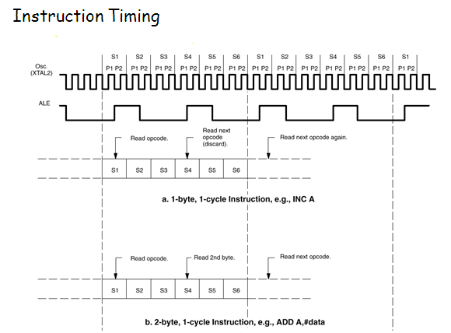
Describe the timing diagram of external data memory read cycle of 8051.(Dec 2018)
MOVX
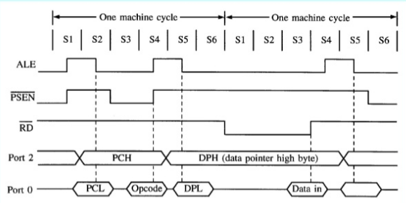

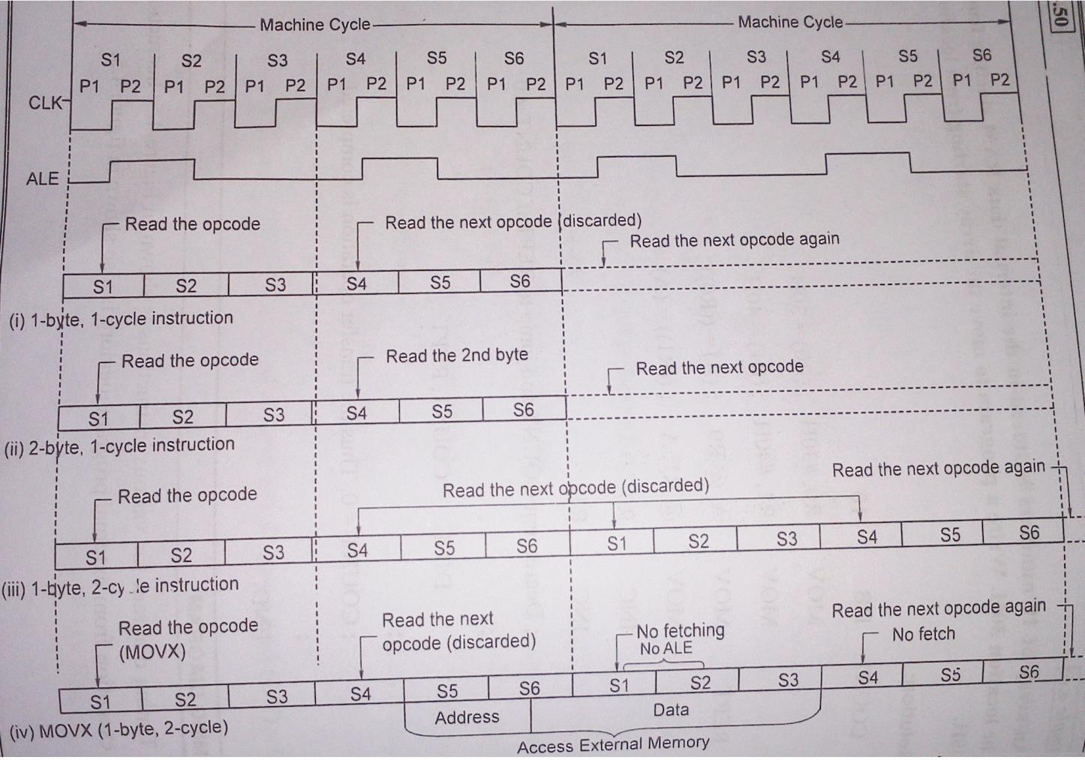

P₀ = Port 0
P₂ = Port2
PCL = Low byte of PC
PCH = Higher byte of PC
  - Timing diagram of the MOVX instruction is shown above.
- Each machine cycle consists of 6 states namely S1, S2 … S6. Generally arithmetic and logic operations take place during phase 1 and internal register-to-register transfer takes place during phase 2.ALE signal is activated during S1 P2 and S2 P1 and it is activated once again during S4 P2 and S5 P1.

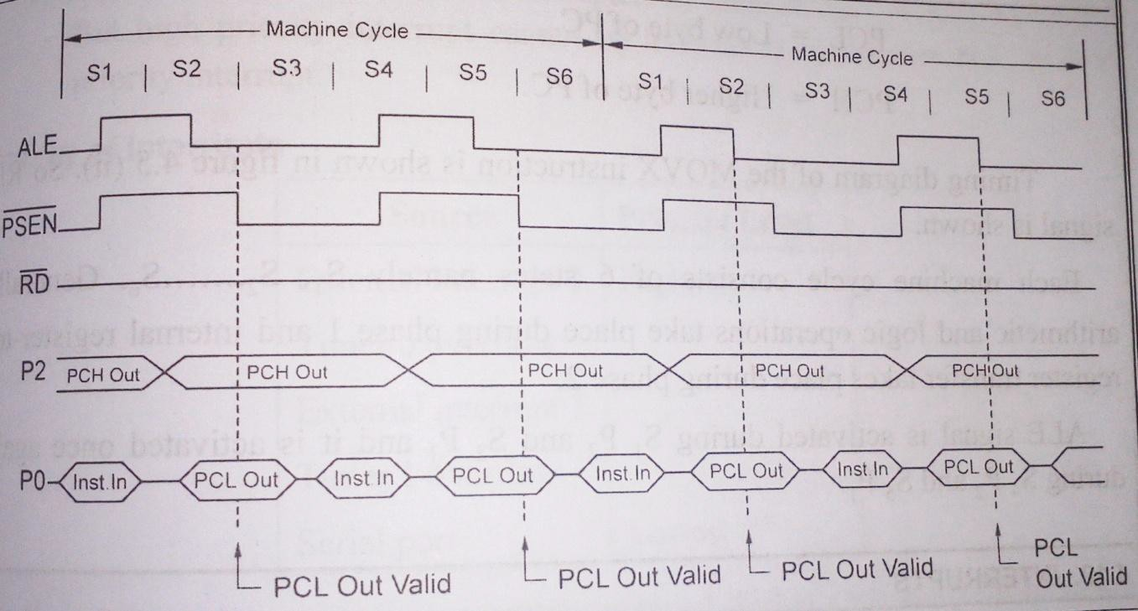

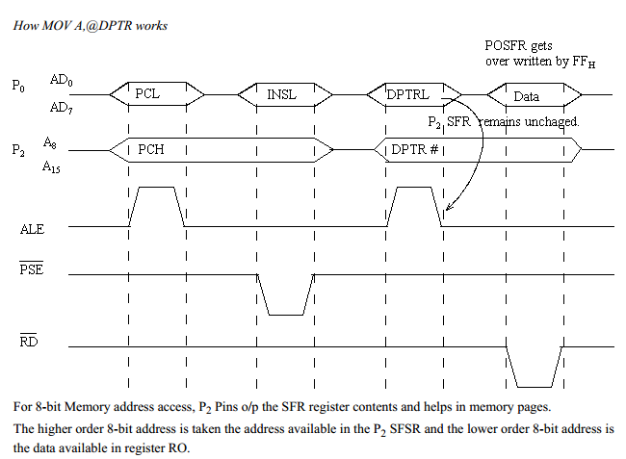
************************************************************************************

SAMPLE PROGRAMS:
- Add two 8-bit numbers

MOV A, #30H ; (A)← 30
ADD A, #50H ; (A)←(A) + 50H

- Add two 16- bit numbers

MOV DPRT, #2040H ; (DPTR)← 2040H (16 bit number)
MOV A, #2BH ; (A)← 2BH (lower byte of second 16 bit number) MOV A, #20H ; (B)← 20H (Higher byte of second 16 bit number) ADD A, DPL ; Add lower bytes
MOV DPL, A ; Save result of lower byte addition MOV A, B ; Get higher byte of second number in A
ADD A, DPH ; Add higher bytes with any carry from lower byte addition MOV DPH, A ; Save result of higher byte addition
- Division two 8-bit numbers

MOV A, #90 ; Get the first number in A
MOV B, #20 ; Get the second number in B
DIV A, B ; A+B, Remainder in B and Quotient in A

- Multiply two 8-bit numbers

MOV A, #8F ; Get the first number in A
MOV B, #79 ; Get the second number in B
MUL A, B ; A x B, Higher byte of result in B and lower byte of result in A

- To add two 16 bit BCD numbers

MOV DPTR, #1234H ; Load first number
MOV R0, #20H ; Load lower byte of second number MOV R1, #30H ; Load higher byte of second number MOV A, R0 ; Get the lower byte of second number ADD A, DPL ; add two lower bytes
DA A ; Adjust result to valid BCD MOV DPL, A ; Store the sum of lower bytes
MOV A, R1 ; Get the higher byte of second number
ADDC A, DPH ; Add two higher bytes considering carry of lower byte addition DA A ; Adjust result to valid BCD
MOV DPH, A ; Store the sum of higher bytes
- To find the sum of 10 numbers stored in the array

MOV DPTR, #2200H ; Initialize memory pointer MOVX A, @DPTR ; Get the count
MOV R0, A ; Initialize the iteration counter
INC DPTR ; Initialize pointer to array of numbers
MOV R1, #00 ; Result = 0
BACK: MOVX A, @DPTR ; get the number ADD A, R1 ; A← Result + A
MOV R1, A ; Result ← A
INC DPTR ; Increment the array pointer
DJNZ R0, BACK ; Decrement iteration count if not zero repeat MOV DPRT, #2300H ; Initialize memory pointer
MOV A, R1 ; Get the result
MOVX @DPTR, A ; Store the result

*************************

